**Teacher’s Assessment - I**

**Problem Statement :-**

Create a Gym Membership System for Power Gold Gym by creating a class

GymMembershipSystem, where

* Class Variables: String gymName, String membershipPlan, double amount; ○ Gym Name, Membership Plans and amounts shall be initialized and should not be changed.

* Class Methods:

○ Design a method to display the membership plans (regular|prime) and their membership amount per year (Rs. 12000 | Rs. 240000)

■ void display();

○ Design a method to display the membership plans monthwise. An integer value is to be passed as a parameter and the method calculates the amount at runtime, displaying the amount

○ For example: void display(2) : scenario for finding the membership plan for two years. It shall print, Rs. 2000 for Regular and Rs. 4000 for prime.

■ void display(int)

Create a subclass Member Class extends the base class GymMembershipSystem ● Class Variables: int id, String name, int mobile, char gender (M: Male, F:

Female, O: Others) ● Class Methods:

○ Design a method to register a member for the Gym Membership

■ void registerMember(id,name,mobile,membershipPlan)

○ Design a method to renew the membership of an already registered member.

■ void renewMembership(id)

■ If id = valid, it shall first display the current membership status of the member and then ask the renewal details (type of membershipPlan and display the amount required to register for it and display a final message as “membership renewed”.)

■ If id = invalid, it shall display error message “Invalid ID”

○ Design a method to cancel membership

■ void cancelMembership(id)

■ If id=valid and the remaining membership is less than 3 months, display “Membership is canceled with No refund”

■ Else, if id=valid and the remaining membership is in between 4 months to 1 year, display “Membership is canceled with 25% refund”

■ Else, if id=valid and the remaining membership is greater than

1 year, display “Membership is canceled with 50% refund”

■ Else, if id=invalid, display error message “Invalid ID”

Create a subclass CheckInRecord Class extends the base class

GymMembershipSystem

● Class variables: checkInTime, checkOutTime ● Class methods:

○ Design a method which updates a time when a member checks in the gym. It shall also print the collective information of the gym member.

■ void enterGym(id);

○ Design a method which updates a time when a member checks out from the gym, including the total time gymed today. It shall also print the collective information of the gym member.

■ void leaveGym(id);

Create a subclass GymStatistics Class extends the base class

GymMembershipSystem

* Class Variables: activeMember (boolean), revenueGenerated(double),

totalMembershipDuration(double)

* Class Methods:

○ Sets the statistics of the various class members such that:

■ activeMember: true if membership is active | false if canceled

■ revenueGenerated: total fee paid ■ totalMembershipDuration:

* If active: total duration of active membership plan
* If canceled: total duration till cancellation.

○ Display the current statistics of all the members of the gym, displaying their information along with class variables.

Create a main class where perform the following tasks:

1) Create an array of objects of 12 members:

1. 5 members of Regular Membership, where 2 are active and 3 are now canceled.
2. 5 members of Prime Membership, where 2 are active and 3 are now canceled.

1. Print only the records where the membership is still active.
2. Print only records of female members, irrespective of the membership plan.

Code :-

class GymMembershipSystem {

    static String gymName = "Power Gold GYM";

    String membershipPlan;

    double amount;

    void display() {

        System.out.println("membership Plans");

        System.out.println("Regular: Rs. 12,000 per year\n Prime: Rs. 24,000 per year");

    }

    void display(int month) {

        System.out.println("your " + month + " month plan consist of" + amount / 6 + " rupees");

    }

}

 import java.util.*;

 class Member extends GymMembershipSystem{

    int id;

    String name;

    int mobile;

    char gender;

    int remainingMembership;

    CheckInRecord c1;

    Gymstatics g1;

    Member(CheckInRecord c1, Gymstatics g1){

        this.c1 = c1;

        this.g1 = g1;

    }

    void registerMember(int id, String name,int mobile, String membershipPlan, char gender){

        this.id = id;

        this.name = name;

        this.mobile = mobile;

       this.membershipPlan = membershipPlan;

       this.gender = gender;

    }

    void info(){

        System.out.println("Members Information : \n" + this.name + "\n" + this.gender +"\n"+ this.id +"\n"+ this.mobile +"\n"+ this.membershipPlan);

    }

    void renewMembership(int id){

        if(this.id != id){

        System.out.println("invalid id");

        return;

        }

        Scanner sc = new Scanner(System.in);

        System.out.println("your current status is : " + this.membershipPlan);

        System.out.print("enter the membership Plan : ");

         this.membershipPlan = sc.nextLine();

        if(this.membershipPlan.equals("prime")){

            System.out.println("amount payable is : 24000" );

        }

        else if(this.membershipPlan.equals("regular")){

            System.out.println("amount payable is : 12000" );

        }

        System.out.println("Your membership was Renewed successfully");

    }

    void cancelMemebership(int id){

        if(this.id != id){

            System.out.println("invalid id");

            return;

            }

        if(remainingMembership < 3){

            System.out.println("Membership canceled with no refund");

        }

        else if(remainingMembership >= 4 && remainingMembership <= 12){

            System.out.println("Membership canceled with 25% refund");

        }

        else if(remainingMembership > 12){

            System.out.println("Membership canceled with 50% refund");

        }

        this.membershipPlan = null;

        g1.activeMember = false;

    }

}

 class CheckInRecord extends GymMembershipSystem{

    double checkInTime, checkOutTime;

    Member m1;

    CheckInRecord(){

    }

    CheckInRecord(Member m1, double checkInTime, double checkOutTime)

    {

        this.checkInTime = checkInTime;

        this.checkOutTime = checkOutTime;

        this.m1 = m1;

    }

    void info(){

        System.out.println("Members Information : \n" + m1.name + "\n" + m1.gender +"\n"+ m1.id +"\n"+ m1.mobile +"\n"+ m1.membershipPlan);

    }

    void enterGym(int id) {

        System.out.println("Member checked in: " + id);

        info();

    }

    void leaveGym(int id) {

        System.out.println("Member checked out: " + id + "\n" + "Total Time Gymed today = " + Math.abs(checkOutTime - checkInTime));

        info();

    }

}

 class Gymstatics extends GymMembershipSystem{

    boolean activeMember;

    double revenueGenreated, totalMembershipDuration;

    Member m1;

    Gymstatics(){

    }

    Gymstatics(boolean activeMember, double revenueGenreated, double totalMembershipDuration, Member m1){

        this.activeMember = activeMember;

        this.revenueGenreated = revenueGenreated;

        this.totalMembershipDuration = totalMembershipDuration;

        this.m1 = m1;

    }

    void info(){

        System.out.println("Members Information : \n" + m1.name + "\n" + m1.gender +"\n"+ m1.id +"\n"+ m1.mobile +"\n"+ m1.membershipPlan);

    }

    void setStatistics(){

        if(this.membershipPlan.equals(null)){

            this.activeMember = false;

        }

        else

        this.activeMember = true;

       this.revenueGenreated = this.amount;

       info();

    }

}

public class Main {

    public static void main(String[] args) {

        Member m[] = new Member[10];

        for(int i = 0; i < 10; i++){

            m[i] = new Member(new CheckInRecord(m[i], 9, 5), new Gymstatics(true, 24000, 12, m[i]));

        }

        // Regular Members

        m[0].registerMember(0, "sujal", 999999999, "regular", 'm');

        m[1].registerMember(1, "prajakta", 199999999, "regular", 'f');

        m[2].registerMember(2, "pratik", 119999999, "regular", 'm');

        m[3].registerMember(3, "vansh", 111999999, "regular", 'm');

        m[4].registerMember(4, "vedant", 111199999, "regular", 'm');

        // Prime Members

        m[5].registerMember(5, "sujal1", 999999999, "prime", 'm');

        m[6].registerMember(6, "prajakta1", 199999999, "prime", 'f');

        m[7].registerMember(7, "pratik1", 119999999, "prime", 'm');

        m[8].registerMember(8, "vansh1", 111999999, "prime", 'm');

        m[9].registerMember(9, "vedant1", 111199999, "prime", 'm');

        m[2].remainingMembership = 5;

        m[3].remainingMembership = 9;

        m[4].remainingMembership = 8;

        m[7].remainingMembership = 2;

        m[8].remainingMembership = 2;

        m[9].remainingMembership = 13;

        m[2].cancelMemebership(2);

        m[3].cancelMemebership(3);

        m[4].cancelMemebership(4);

        m[7].cancelMemebership(7);

        m[8].cancelMemebership(8);

        m[9].cancelMemebership(9);

       System.out.println("following is the information of active members: ");

        for(int i = 0; i < 10; i++){

          if(m[i].g1.activeMember){

            m[i].info();

          }

        }

        System.out.println("following is the information of only female members: ");

        for(int i = 0; i < 10; i++){

            if(m[i].gender == 'f'){

                m[i].info();

            }

        }

    }

}

Output :-

Female members only :

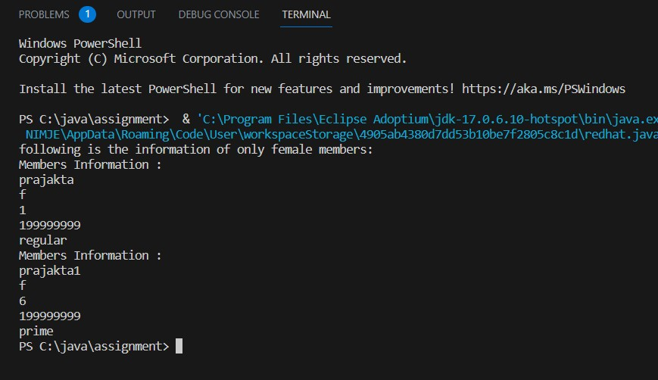

Active members only :

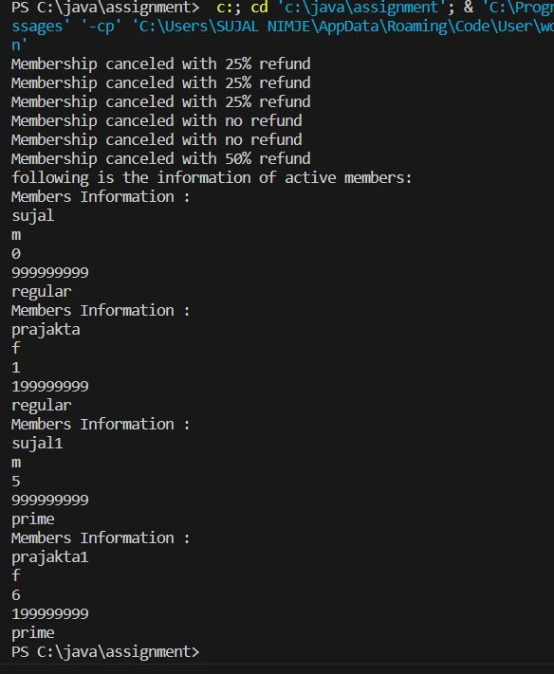

Renewing membership :

